Power BI Direct Connectivity Asssignment

- What are the 3 main connectivity modes in Power BI?

Mode | Description | Best For
Import Mode | Data is imported into Power BI. Most performant and commonly used. | Fast performance, offline data analysis
DirectQuery | Queries are run live against the data source. Data is not stored in Power BI. | Real-time dashboards, large datasets
Live Connection | Connects to an existing data model like SSAS or Power BI Dataset. | Enterprise-scale models, centralized BI

- What are the two gateways in Power BI?

Gateway Type | Use Case
Personal Mode | For one user; used with Power BI Desktop only; no central management.
Standard/Enterprise Mode | Multi-user; used for shared datasets and central management. Recommended.

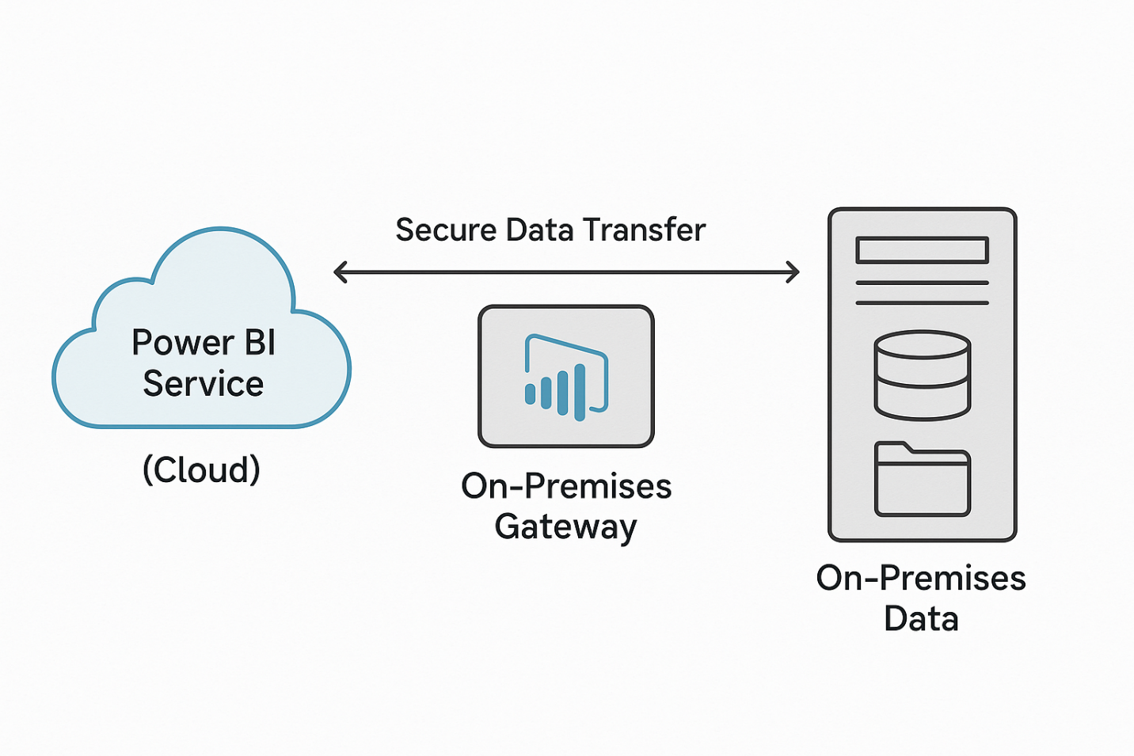
- How gateway works ? Explain with diagram

- What is the difference Cloud based data and On premises data?
Aspect | Cloud-Based Data | On-Premises Data
Storage Location | Stored on cloud platforms (e.g., Azure, Salesforce) | Stored within local servers or data centers
Access | Accessible via internet | Requires secure connection (e.g., Gateway)
Example Sources | Azure SQL, SharePoint Online, Web APIs | SQL Server, Oracle, SAP HANA, File System
Gateway Needed? | No | Yes

- What are the step to use Gateway.
• Download the Gateway:
- Go to Power BI Service → Settings → Manage Gateways → Download.
• Install Gateway:
- Choose Standard Mode for enterprise use.
- Install it on a machine that can access your on-premises data source.
• Sign in and Register Gateway:
- Sign in with your Power BI account.
- Register the gateway to your tenant.
• Add Data Sources:
- Go to Power BI Service → Manage Gateways.
- Add your on-premises data source (e.g., SQL Server, Oracle).
- Enter credentials.
• Use the Gateway in Power BI:
- In Power BI Desktop, use the same data source and name.
- Publish the report.
- In Power BI Service, go to Dataset Settings → Gateway connection → Select the configured gateway.
• Schedule Refresh (Optional):
- Set up refresh frequency (daily/hourly).

